WEEK 8 – TITAN EYE DATABASE RELATIONSHIP ANALYSIS USING JOINS
INNER JOIN:
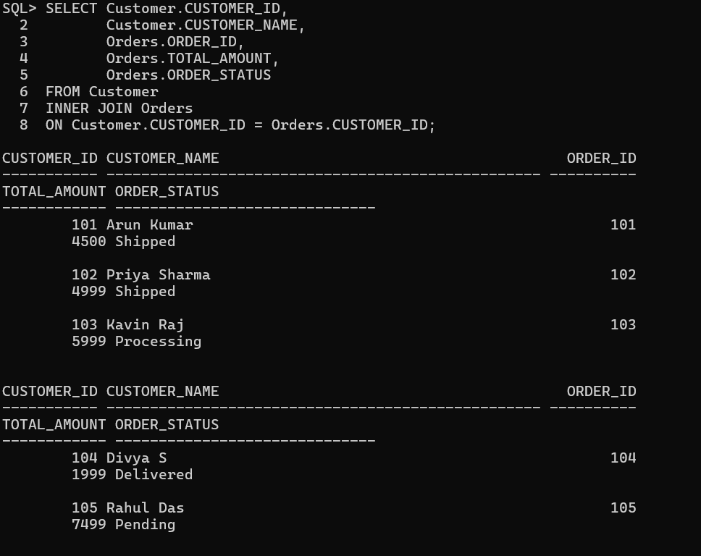
LEFT JOIN – CUSTOMER AND ORDERS:
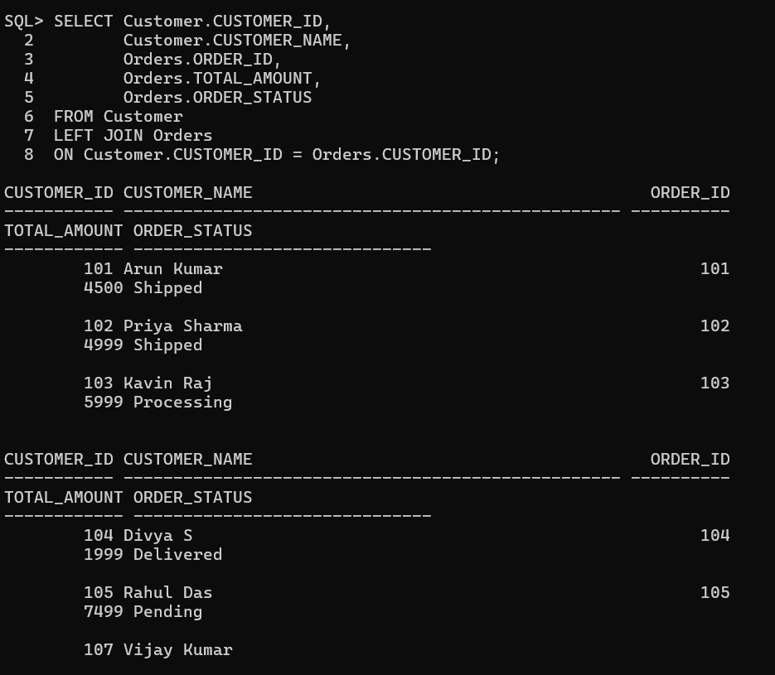
RIGHT JOIN – CUSTOMER AND ORDERS:
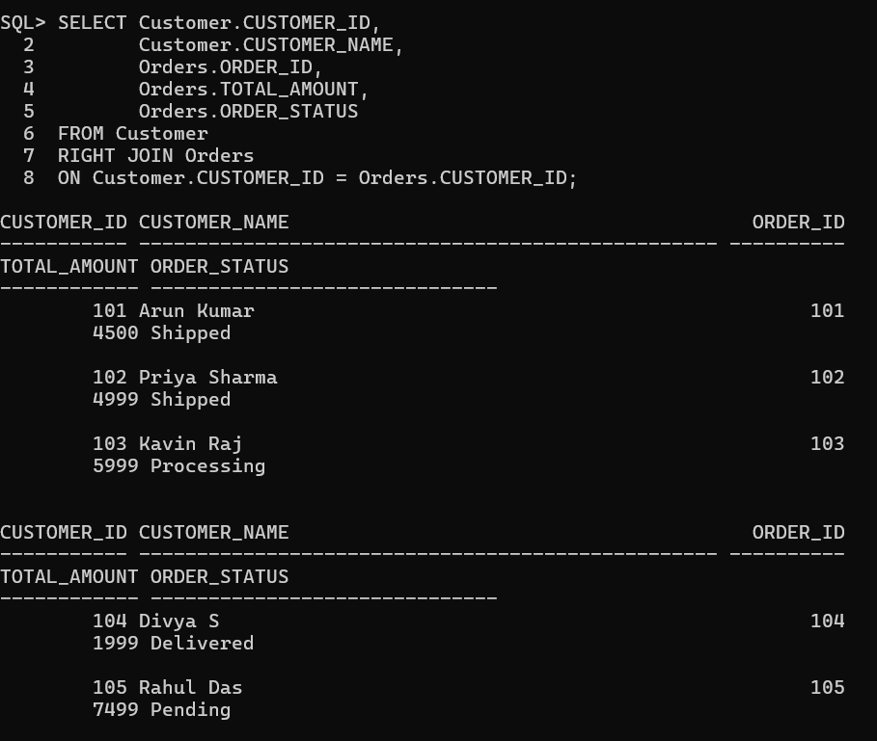
COMBINE CUSTOMER, ORDERS, ORDER_ITEM AND PRODUCT:
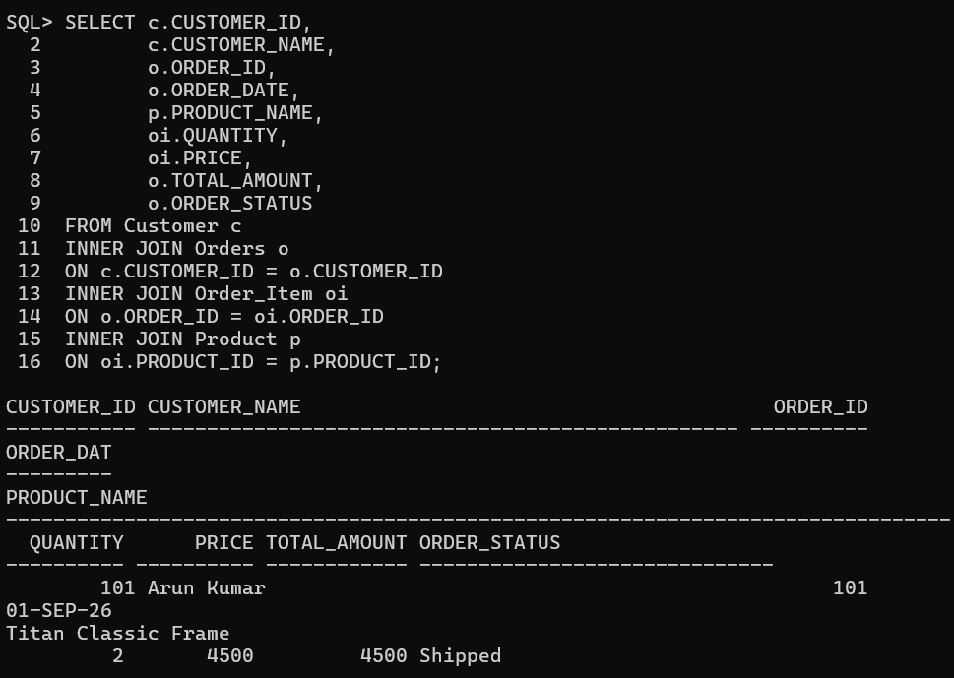
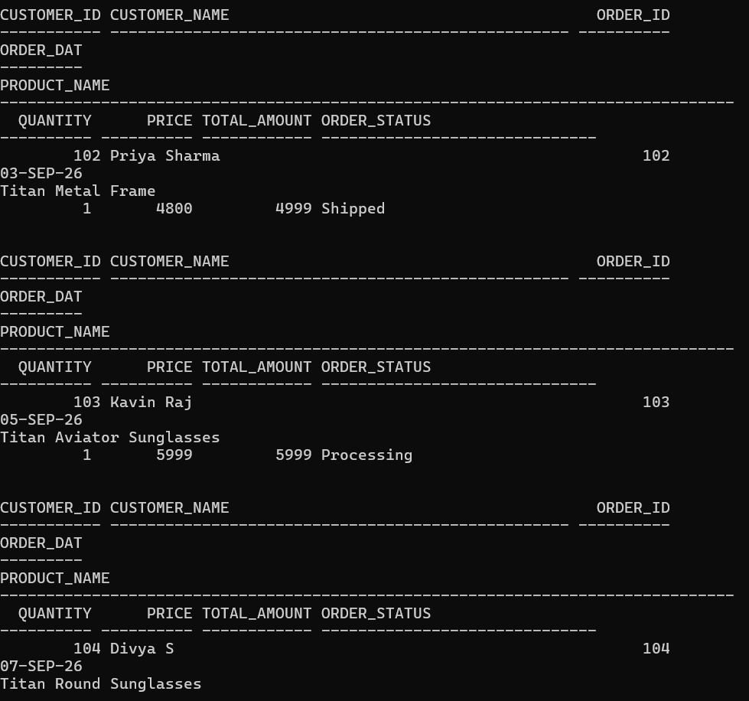

RETRIEVE COMPLETE ORDER DETAILS USING MULTIPLE TABLE JOINS:
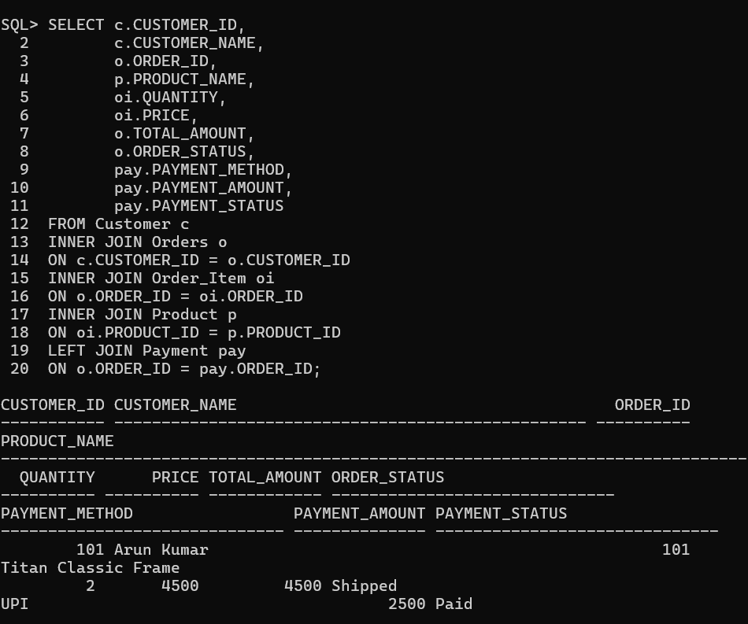
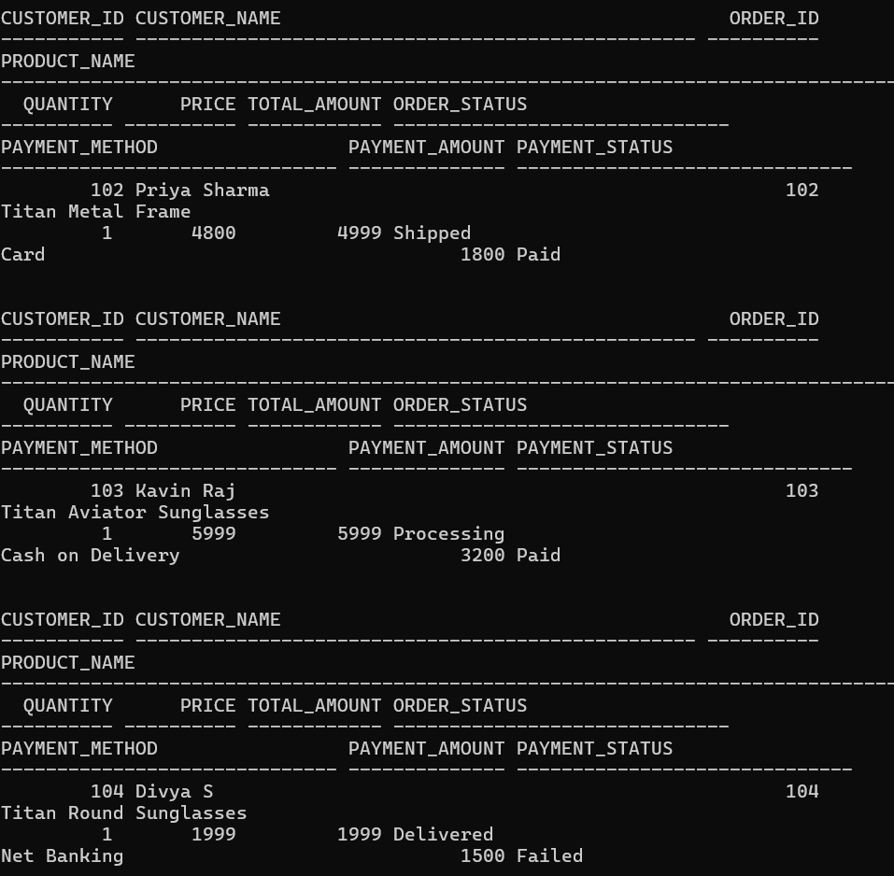
DISPLAY CUSTOMER PURCHASE HISTORY USING JOIN:
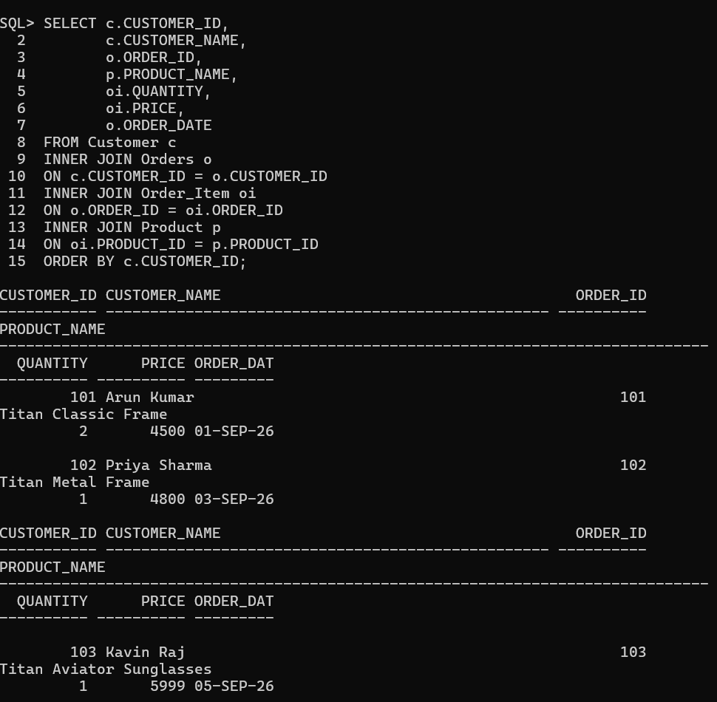
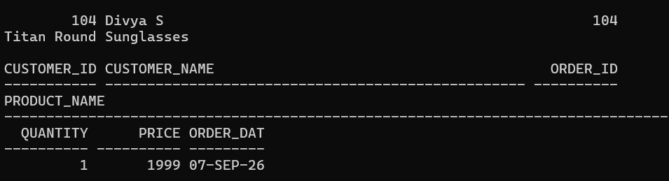
GENERATE CUSTOMER ORDER REPORT USING JOIN
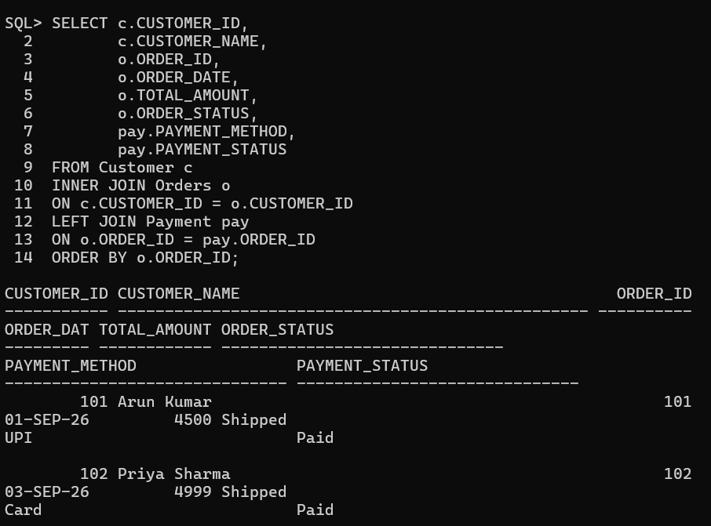

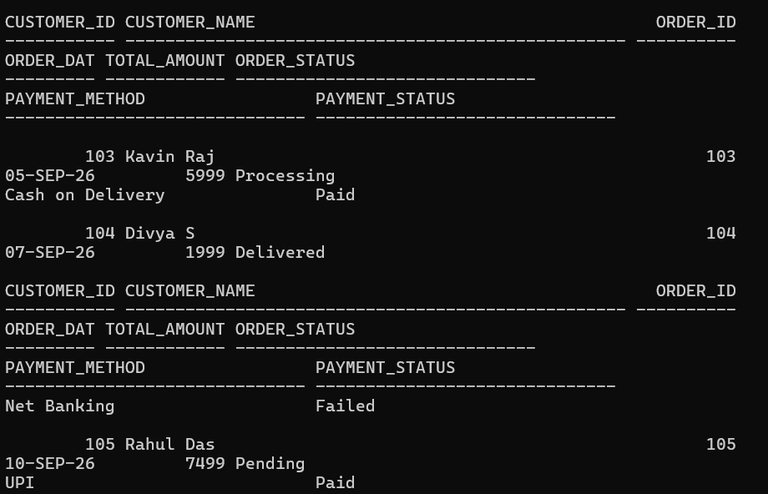
PRODUCT SALES REPORT USING JOIN AND GROUP BY:
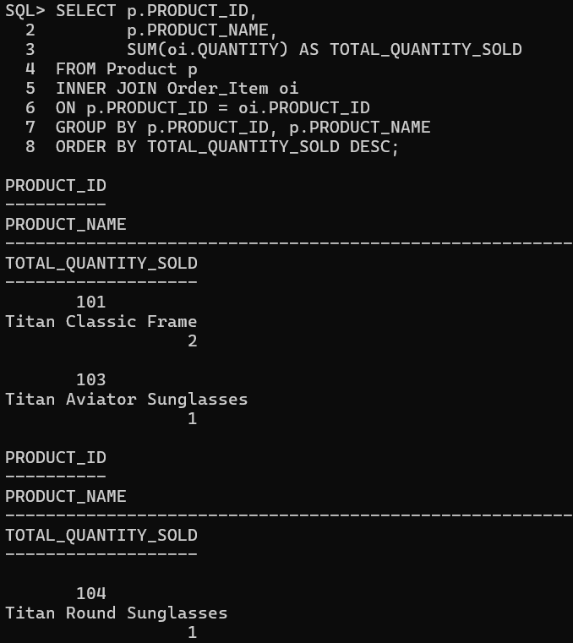
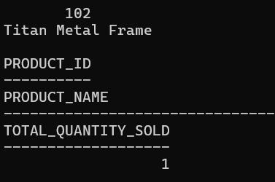
PAYMENT REPORT USING JOIN:
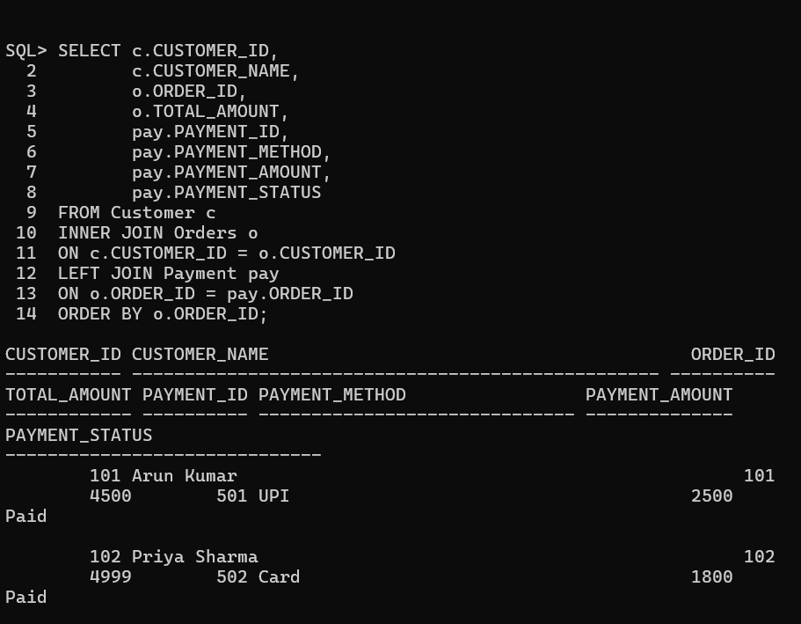
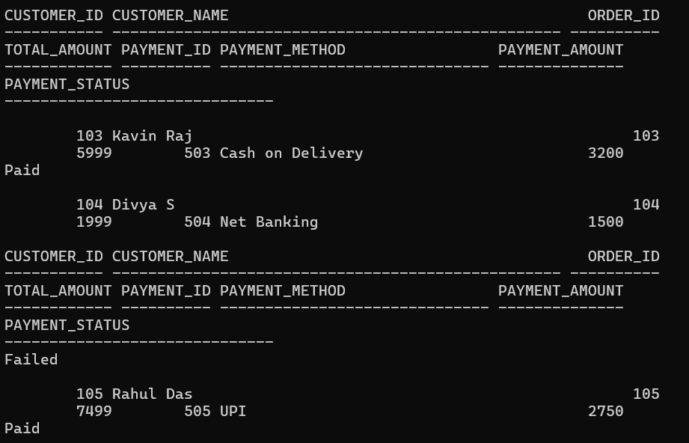
DISPLAY ORDERS WITH PAYMENT STATUS:
